**Front-End Test – Exe 1**

*Java script was used.

1. Login to Wiki page via Chrome

<https://www.wikipedia.org/>

1. Press F12 so Dev Console will open
2. Paste below code and press enter. Code below return the search of a desired string “tomer”

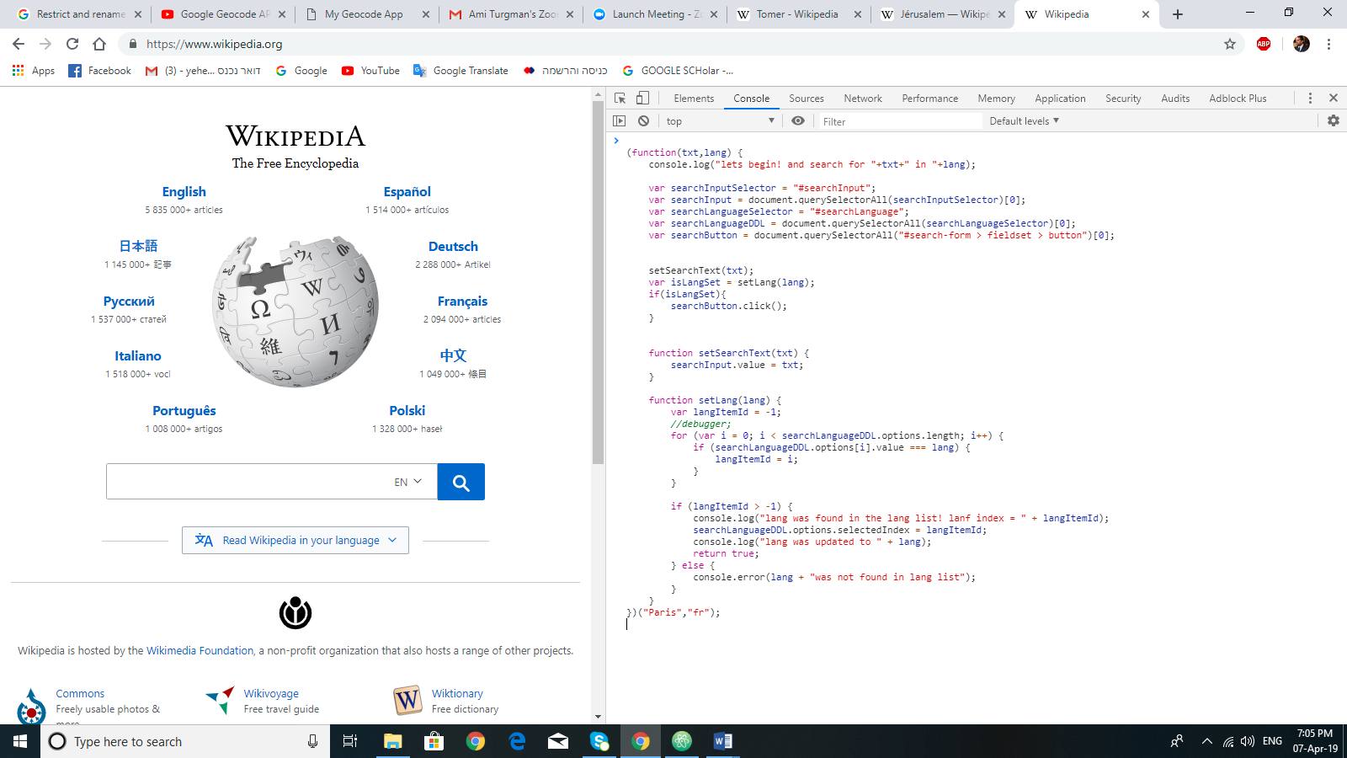

(function(txt,lang) {

console.log("lets begin! and search for "+txt+" in "+lang);

var searchInputSelector = "#searchInput";

var searchInput = document.querySelectorAll(searchInputSelector)[0];

var searchLanguageSelector = "#searchLanguage";

var searchLanguageDDL = document.querySelectorAll(searchLanguageSelector)[0];

var searchButton = document.querySelectorAll("#search-form > fieldset > button")[0];

setSearchText(txt);

var isLangSet = setLang(lang);

if(isLangSet){

searchButton.click();

}

function setSearchText(txt) {

searchInput.value = txt;

}

function setLang(lang) {

var langItemId = -1;

//debugger;

for (var i = 0; i < searchLanguageDDL.options.length; i++) {

if (searchLanguageDDL.options[i].value === lang) {

langItemId = i;

}

}

if (langItemId > -1) {

console.log("lang was found in the lang list! lanf index = " + langItemId);

searchLanguageDDL.options.selectedIndex = langItemId;

console.log("lang was updated to " + lang);

return true;

} else {

console.error(lang + "was not found in lang list");

}

}

})("Paris","fr");

Section 4

document.getElementById("firstHeading").innerText

Section 5

document.getElementById("firstHeading").getAttribute('lang')

Section 6

var links = document.getElementsByClassName('interlanguage-link-target')

undefined

for(var i=0; i<links.length; i++) {

if (links[i].innerText == 'English') console.log('English exists');

}

